**Setting Up an FTP Server on Windows Server 2022**

**Practical**

1. **Install FTP Server Role**

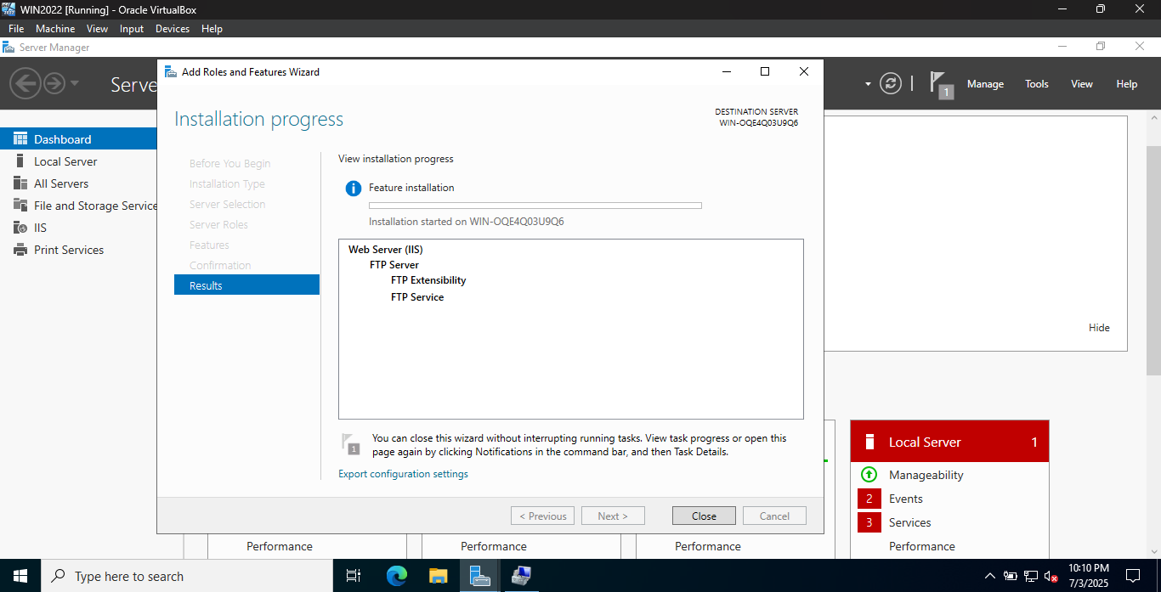

1. **Configure FTP Site**

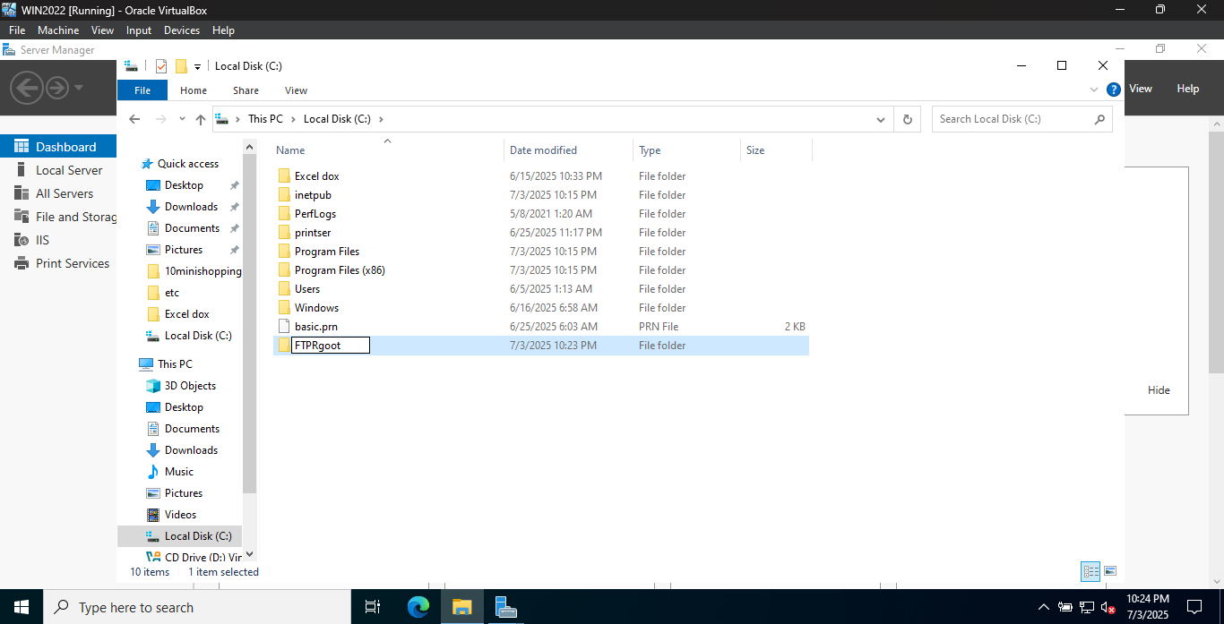

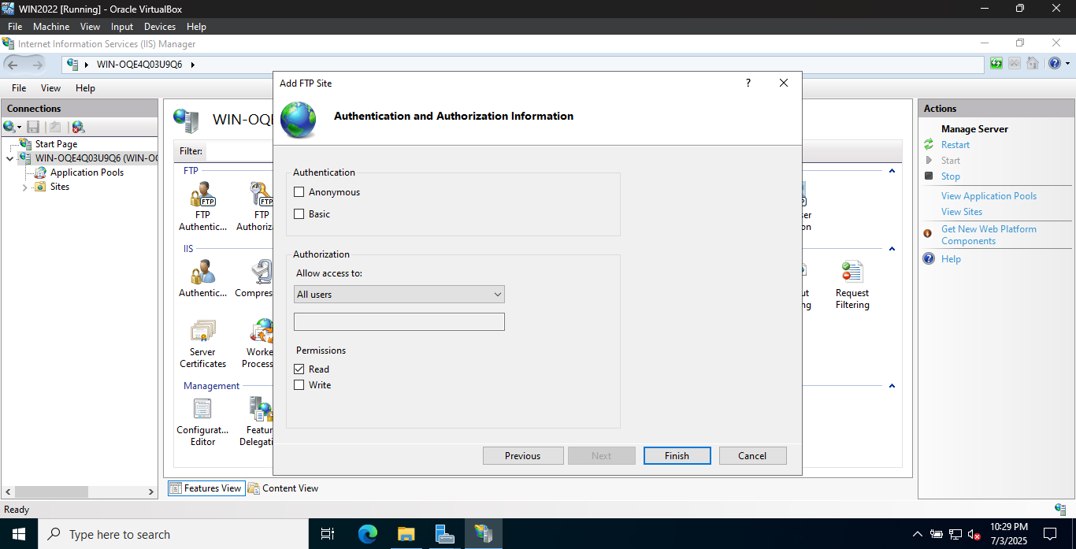

1. **Create FTP User and Permissions**

